Brian Solis advises starting off an influencer marketing program with a pilot campaign.

Before reaching out to anyone, develop a list of pros and cons for each authority based on their work or activity to date to qualify a core set of individuals who are likely to become part of a pilot campaign. The individuals you choose should offer a notable balance of reach, reputation, relevance, and resonance. *— Brian Solis*

Start by contacting these initial influencers using plain and clear language briefly introducing you and your business. Explain why you have contacted them and highlight how what you’re sharing will bring benefits to them. Remember the concept of borrowing ‘social capital’, it all depends on being able to offer your influencers something in return. This has to be a mutually beneficial relationship.

Of course we have to achieve our goals and objectives but once we identify our influencers and we figure out and what they’re about, the next questions to ask are ‘What do they like to do? What would make their lives easier?’ Just knowing what your influencers like to do and how they like to share that’s going to shape your program in a much better way. *— Deirdre Breakenridge*

As Deidre highlights it is incredibly important to understand your influencers and what they like to share on the web. You can then tailor your content to suit. In the case of our fictional car company, Prezla, the team identify the automotive influencers that like to tweet concept images, compare statistics and attend exclusive events, so they start preparing collateral to be able to offer this.

Remember each approach should be different. Try to tailor your content and the way you present it for each influencer you engage.

Treat this outreach as an ongoing conversation. There’s no end result, just closer connections built over time. During your outreach you should be keeping track of your interactions with influencers in a CRM style system and ranking them by the level of engagement with your brand. Here’s an example of how you might do this:

1. The starting point before your influencers knows about you or your brand
2. Initial contact, when you’ve reached out but haven’t yet received a reply
3. Your influencer acknowledges they’ve received your message
4. Your influencer starts asking interesting questions
5. Your influencer amplifies a message you’ve shared
6. Your influencer turns into an advocate by supporting you without a prompt

“Influencer Marketing” this is what you are trying to do. This will be the heading.

When you work with these influencers to promote your product, that’s called influencer marketing. Reaching out to them to get a deal done is influencer outreach.

there’s been an explosive use of Adblock in recent years that makes it much harder for businesses to rely on traditional paid media.

With Adblock expected to rise 30% year over year, it’s highly likely that the day will come when online ads are a ghost of our past. Even now, relying on them might not be the most efficient use of your marketing budget.

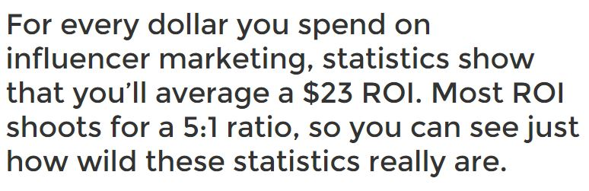

ROI is return on marketing investment

Remember in your planning that using influencers in unique ways always stands out, like in 2014 when Hubspot asked influencers to lend advice about influencer marketing for an infographic.

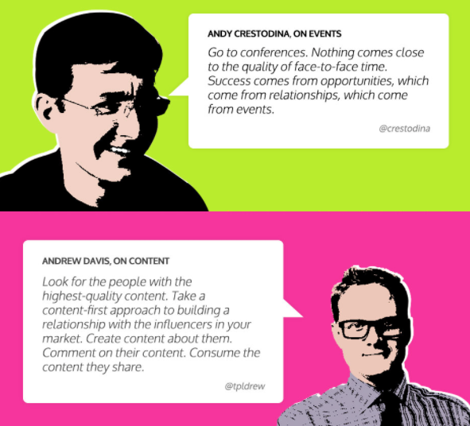

After you’ve determined what your project (way of using the influencers) is, it’s wise to establish goals that are within reach and mapped out over time. I like to use the traditional SMART methodology (SS one)

This is a method loved by marketers everywhere, and if you adhere to it, you’ll have a clear path forward for every project you ever attempt.

Here are some examples of goals you could create for your project:

1. This influencer marketing campaign should improve conversion rates by x% by y date.
2. I plan to spend $x on research, design, and distribution.
3. I plan for this campaign to take x long and stay active for y long.

**Finding the right influencers**

The key to finding the right influencers is to remember that the more you know about your target, the better you can create a pitch that will engage and sell them on your idea.

I used two different processes for tracking down influencers.

The first and easiest one is to simply Google the keywords you are targeting.

The second process I used was an influencer search on Buzzsumo. You get a customized list of individuals related to your search terms (I used content marketing here). You can also gain quick access to their social media, website, and other helpful information.

not every project has to rely on high-profile influencers to achieve its goals. In fact, most don’t.

What I’m talking about is the practice of using niche-specific micro-influencers that have more “modest” online followings. I say “modest” because their following is still large by some standards, only they’re smaller than the millions of followers a high-profile influencer would have.

And this is good, too, because according to Markerly a large follower count doesn’t necessarily mean your chosen influencer is the best option.

They put the “sweet spot” of comment activity and following between in the 10k-100k followers window.

ExpertVoice found that Micro Influencers improve your chances of conversions even more than the normal batch of influencers. In fact, micro-influencers achieved 22.2 times more conversations than average when they recommended products to their audience.

What’s more, they also found that 82% of consumers reported that they were highly likely to follow a recommendation made by a micro-influencer.

Example -

This particular channel only has 23,000 subscribers, but Jord’s influencer video got more than 13,000 views. That’s thousands of more eyes and a positive review from a leader of a small online community, which is worth its weight in gold.

They also provide influencer giveaway campaigns that have a promo code attached. So not only is Jord hoping for a good review, they’re incentivizing the influencer’s audience to check out their product with a discount. And the benefit to the influencers? They get a nice watch. All in all, this is a perfect example of how you can use micro-influencers in an extensive campaign.

But how do you find these influencers? To help shortcut your micro-influencer search, I recommend a service like [Hypr](https://hyprbrands.com/" \t "_blank).

You can search either by audience or influencer with the option to narrow your search based on a variety of demographics. For example, if you want to look for influencers who help their following be more productive, then you could enter a search term for “productivity.”

So how do you fine-tune your search to find micro-influencers? Simply refine by followers.

To find out if they really are a good fit for your end goals, all you need to do is click on their individual profile. This gives you a ready-made look into the specifics of their audience and gives you an idea of how active and engaged their profile is.

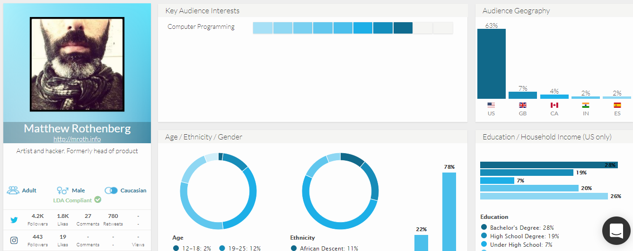

Within your influencer consideration, you should also think about how you handle “compensating” your influencers. And a little extra exposure is not sufficient.

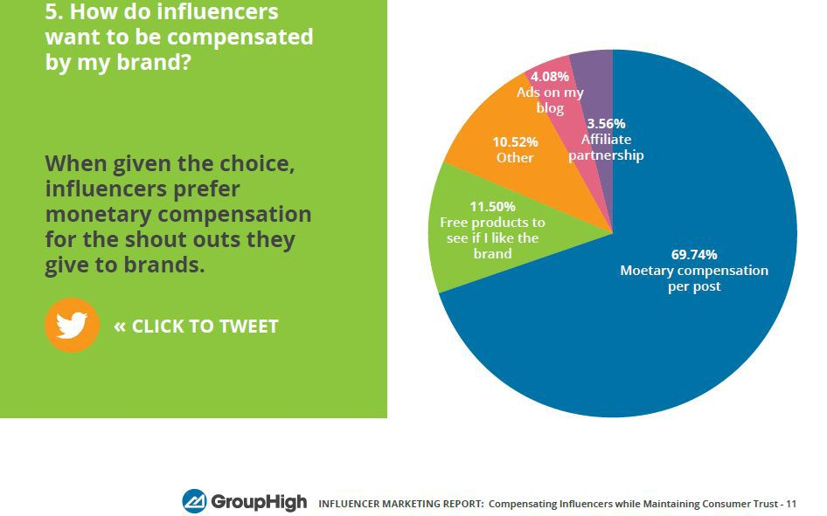

Here’s a list of other “compensation” methods:

**Shout out**

**Product discount or giveaway** - Offering a discount on your services

**Commission** - If you have an influencer that keeps coming back into your efforts and leads to bigger sales, setting them up with a commission might not be a bad idea.

For other methods - <https://www.searchenginepeople.com/blog/16052-influencer-marketing-101-part-3.html>

**The Pitch**

If you want to look at [template examples](https://www.gmass.co/blog/5-high-yield-cold-email-outreach-templates/), that’s fine, but I don’t advise just treating them as a copy-paste effort for your project.

Modify every pitch to your specific audience. I recommend being specific to each influencer too.

Start by personalizing the pitch. Don’t start your pitch letter with “Dear blogger” or “Dear influencer.” That’s just going to be ignored altogether by 99% of your recipients.

It’s also not a good idea to start by talking about you, how great you are, or how important this opportunity is for them. Focus instead on building the relationship with your influencer.

Share your thoughts on their content, work, or expertise. It’s usually a good tactic to reference a post or podcast that resonated with you and how that led to your decision to reach out.

Keep your pitch simple. The offer should be clear, and your desired outcome shouldn’t be veiled (meaning – hidden from the person).

Be upfront about how much work the influencer will need to do, and don’t be vague or beat around the bush.

The easier you make it for your influencer to help you, the more likely you’ll get a favourable response. Provide instruction, sample content, or images that they can use or refer to.

Don’t be a burden to them

Lastly, follow good email etiquette:

1. Be short and to the point.
2. Don’t mass pitch.
3. Pique their interest.
4. Don’t suck up.
5. Tell them why you want their endorsement.
6. Share the benefits of your project to their audience.

The most important thing to keep in mind is to keep your email short and direct. Here’s an example of how I reached out to Guy Kawasaki.

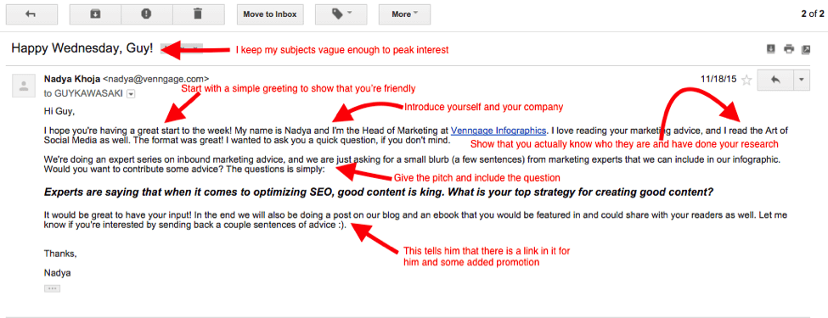

Takeaways:

1. Keep your subject line vague enough to peak interest, but try to address the person by name right off the bat so that it still comes off as personal.
2. Greet them to show you are friendly, but keep it short and sweet.
3. Introduce yourself at the beginning of your email, or simply sign off at the end with your name and company.
4. Research the person you are outreaching to and make your pitch personal. Don’t just copy and paste a generic email template to everyone. These are experts after all and can definitely tell when you’re taking the easy way out.
5. Your pitch or ask should only be a couple of sentences at the most. Don’t go on and on about your company’s philosophy, history or any of that extra information. Get to the point and get out!
6. Finally, offer this person something you know they want. Chances are any marketer or entrepreneur you outreach to understands the value of being featured in a well-researched and promoted piece of content.

It takes some persistence to get people’s attention.

You need to show them how committed you are to getting their attention.

There are seven major errors that many tapping into an influencer’s audience ends up making.

1. Not doing a “1-2 punch.”
2. No follow-up or too few emails.
3. Too many emails.
4. Having an unclear ask (or none at all)
5. Using a one-size fits all approach.
6. No clear goal
7. Failure to quantify the relationship.

Three powerful ways you can change your email’s destiny and reach your targeted influencer.

1. Change your frame of mind. Instead of treating this like networking, try to build a relationship.
2. Go above and beyond what your influencer likely expects.
3. Try to find out why they didn’t respond or denied you. This can help you improve your angle for next time.

**Preparing for Rejection**

That doesn’t mean that I didn’t try to get in touch with the ones who didn’t reply.

The point is, a lot of these people likely get so many emails on a daily basis that my wonderful pitch very possibly got buried somewhere in their inbox.

So what do you do when this happens?

Well, you can send a follow-up email and hope for the best, or you can try to contact them via other channels.

[Twitter is a great way to signal someone](http://www.business2community.com/twitter/8-steps-influencer-marketing-twitter-01320940#uT8zKPeS1T4rl6uT.97) or remind them that you sent an email. It indicates that you are still awaiting a response.

The reason being that tweeting to someone puts you out in the open and signals to the rest of the world exactly what you are working on.

Many people may find this daunting and a premature unveiling of their content plans. But, sometimes the more you talk about your upcoming projects, the more anticipation you build for them.

If your email goes ignored, send a follow-up one. If that doesn’t work, try using different channels to get in touch with a person.

**SEO**

### SEO targets quality traffic

One of the biggest advantages of SEO is that it’s aninbound marketing strategy. Unlike traditional “outbound” advertising channels, which involve reaching out to consumers whether they want to hear from you or not, inbound methods center on making it easy for your audience to find you when they want information.

These traditional methods, like cold calling, spam emails, and interruptive ads, are done solely with the advertiser’s goals in mind. And many consumers find them downright annoying. Inbound marketing, on the other hand, is much more customer-centric. Instead of interrupting consumers as they’re watching TV or listening to the radio, it involves creating helpful resources and making helpful information more easily accessible.

Then, when users are ready to spend some time researching your industry or learning more about their options for a specific type of product, they can find you on their own.

This is not only much more convenient for consumers but also results in more qualified leads for your business.

In fact, in HubSpot’s most recent [State of Inbound](https://www.hubspot.com/state-of-marketing) report, 59% of marketers said that inbound practices provided the highest quality leads for their sales teams.

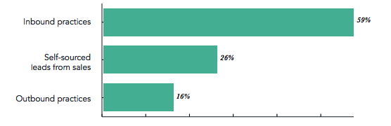

When you focus on attracting users who are actively looking for information related to your industry, products, and services, you’ll be much more effective in reaching your target audience.

### You don’t need to pay for ads in SEO

Google’s organic rankings are based entirely on what its algorithm determines to be the best results for any given query. This means that once you’ve created a page that the search engine deems worthy of directing their users to, it can continue to attract traffic to your site for months (or even years) after you publish it. This is a major difference from PPC ads, which involve a cost every time a user clicks and visits a page. To give you an idea of what just how big of an advantage this is, just consider that the average cost per click (CPC) across all industries is $2.32.

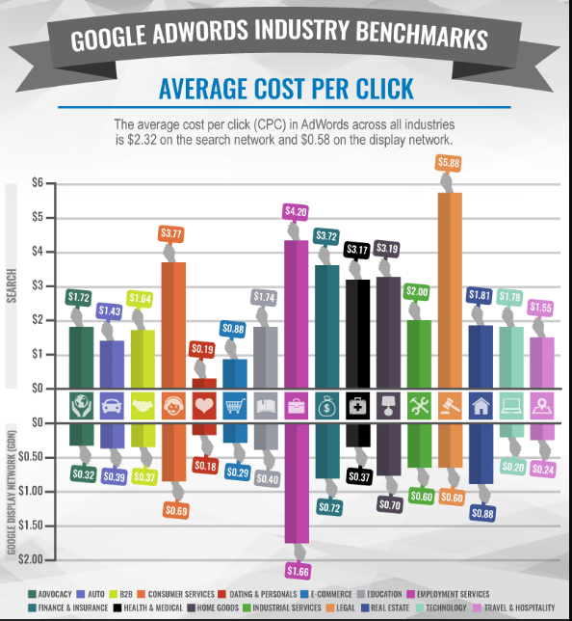

### SEO gets more clicks than PPC

Although PPC ads appear above organic rankings,71.33% of searches result in a click on an organic result on the first page.

### SEO helps PR

The biggest connection between the two lies in link building. Earning links from reputable websites is a main component of any SEO strategy. This means that one of the biggest parts of an SEO professional’s job is to identify opportunities for placement or coverage on industry blogs, news publications, and other relevant sites. And considering that a PR strategy revolves around getting prominent publications and influencers to talk about your company, this presents a huge opportunity. When you use link building research to find new ways to get your brand in front of consumers, you’ll be much more effective in distributing content to potential customers and clients.

### You can move ahead of the competition

 61% of marketers say that improving their SEO and improving their online presence is a top priority.

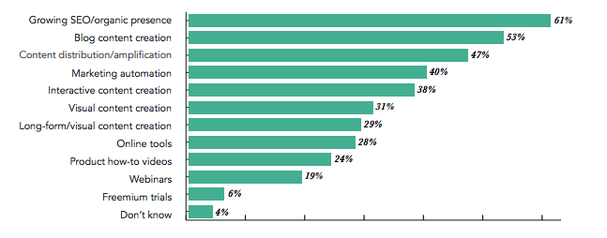

**How to do it –**

Step 1 - Learn what you’re customers are actually searching for

Think about the most common thing a person would type on google to search for something that might be related to your project. Ex. Hydroponics, hydroponic system for home, hydroponic pod etc.

(a) Figure out the most popular way people search for your business - You can use the ideas you’ve already jotted down to do that. Start by doing a Google search for one of the words or phrases on your list. It doesn’t matter how ridiculous or long-winded this phrase is.

Then look for the most common phrase that is coming up. This matters because websites tend to optimize their title tags for SEO.

make sure this is a good main keyword to target by checking out our original search term in [Ahrefs Keywords Explorer](https://ahrefs.com/keywords-explorer).

(b) Understand the other ways people might be searching for the same thing.

take a look at the**SERP overview**for “Dublin hotels” in Keywords Explorer. Take note of the “Kw.”column, which shows how many keywords for which each of the top 10 web pages rank.

The average here is around 150–200 keywords.

In other words, each of these web pages gets traffic from hundreds of other [long-tail](https://ahrefs.com/blog/long-tail-keywords/) and related keywords. That means not everyone types “Dublin hotels” into Google when searching for a place to stay in Dublin. Other people search for the same thing in different ways.

You can start to get a sense of what these other keywords are by analysing more Google search results.

Look for more similar and related phrases that pop up over and over again.

In this instance, we see such phrases as “hotels in Dublin,” “Dublin city hotels,” and “cheap hotels in Dublin.”

If you want even more suggestions, try the **Also rank for** report in Keywords Explorer.

One way to narrow things down to only super relevant results is to take the 2–3 most relevant top ranking pages and paste them into [Ahrefs Content Gap tool](https://ahrefs.com/content-gap). That will unveil the common keywords for which all of those pages rank.

(c) Delve deeper into the more granular searches your customers are making –

A simple way to start is to look at Google autocomplete results. Go to Google and begin typing a query in the search box, but don’t hit Enter. Google will immediately suggest some additional search terms that people have used.

(d) Find popular and engaging topics in your field –

don’t just start a blog and hope for the best—figure out what topics are popular and engaging in your field and create content related to said topics.

For this, I’d recommend starting with [Reddit](https://www.reddit.com/" \t "_blank).

Find a subreddit related to your industry (e.g., [r/irishtourism](https://www.reddit.com/r/irishtourism/)). Look at what people are talking about and which threads are the most popular. You can even filter and sort by the top threads of all time.

Want to take things a step further?

Enter [Content Explorer](https://ahrefs.com/content-explorer).

Content Explorer provides one of the quickest and most reliable methods to understand the most popular and engaging in a given field.

Notice how I used the filters to find pages that get a substantial amount of search traffic even though they only have a handful of links? This allows me to quickly identify relevant popular topics that *should* be easy to rank for.

I can even see the keywords for which each of these pages ranks by hitting “Details” dropdown.

Expand your keyword list by looking literally anywhere else.

**Viral Marketing –**

## Master the target audience.

understand your [target audience](https://www.entrepreneur.com/article/270131). Viral content is only effective if it speaks to people so convincingly that they are eager to share the content.